

**DEPARTMENT OF INFORMATION TECHNOLOGY**

A.P.SHAH INSTITUTE OF TECHNOLOGY

G.B. Road, Kasarvadavali, Thane (W), Mumbai-400615 UNIVERSITY OF MUMBAI

**Academic year: 2022-23**

# Tourist Guidance System

**S.E. - I.T Engineering**

**Submitted By**

### Swapnil Joshi Moodle ID:21104005 Karan Jain Moodle ID:21104008

**Yash Jain Moodle ID:21104041**

**Under The Guidance Of**

#### Prof. Rujata Chaudhari

# CERTIFICATE

This to certify that the Mini Project report on **Tourist Guidance System** has been submitted by Karan Jain (21104008), Yash Jain (21104041) and Swapnil Joshi (21104005) who are Bonafede students of A. P. Shah Institute of Technology, Thane, Mumbai, as a partial fulfillment of the requirement for the degree in **Information Technology**, during the academic year **2022-2023** in the satisfactory manner as per the curriculum laid down by University of Mumbai.

Ms.Rujata Chaudhari

Guide

Dr. Kiran Deshpande Dr. Uttam D.Kolekar Head Department of Information Technology Principal

External Examiner(s) 1.

2.

Place: A.P. Shah Institute of Technology, Thane

Date:

#### ACKNOWLEDGEMENT

This project would not have come to fruition without the invaluable help of our guide **Rujata Chaudhari**. Expressing gratitude towards our HOD, **Dr. Kiran Deshpande**, and the Department of Information Technology for providing us with the opportunity as well as the support required to pursue this project. We would also like to thank our teacher Prof Shital Agrawal who gave us her valuable suggestions and ideas when we were in need of them. We would also like to thank our peers for their helpful suggestions.

**TABLE OF CONTENTS**

1. Introduction. 1

1.1 Purpose 2

* 1. Objectives. 3

1.3 Scope 4

1. Problem Definition 5
2. Proposed System 6
   1. Features and Functionality 7
3. Project Outcomes 8
4. Software Requirements 9
5. Project Design ………………………………………………………………………….14
6. Project Scheduling …………………………………………………………………….. 20
7. Conclusion ……………………………………………………………………….. 21
8. Reference 22

# Chapter 1

# Introduction

Tourism management system is user friendly Desktop Project which can be used for local traveling and it results into good user experience while travelling.It provides description of places and some related information about them.It also provides some hotel schemes and their websites link to book hotel from.Our project is well developed that user gets authentic information about the places along with the Distance from their current location provided,its Latitude, Longitude, Address as well as the name of the relevant places nearby to the user with the help of Foursquare API which indicates and proves that our Project gives accurate information about the places.Secondly,user can as well see his Profile and logout from home page as well.Some of the recommended places are provided by us on the home page as well.Our project mainly focuses on the places in GOA and MUMBAI.Tourism management system is built upon three Foundations, for Frontend Tkinter Library is used,for Backend pure Python ,and SQlite3 as our Database

Tourism management system is used to book a tour from anywhere in the world by a single desktop application which will help the user to know all about the places and tour details in a single website. Then the users can sign in and book each project. It is the easiest platform for all travelers which can be easily booked and know all the details. Tourism Management system is a tourism business It is also called travel technology solution for agencies & tour operation. Nearly Everyone goes on a vacation for this ‘a Tourism management system’ would play a vital role in planning the perfect trip. The tourism management system allows the user of the system access to all the details such as location, events, hotels, places etc.

### Purpose:

This is a customer oriented project. The objective of the project is to guide people about traveling to places who are new to a particular area. This project will provide the best possible location outcomes after the user has entered his current location and this current budget.

In addition to the traveling guidance we are also providing with the hotel & Restaurant booking system, doing so users don’t have to run all over the city for the booking. The purpose of this project is to provide the complete information about the hotel available for a tour. There are 2 different types of users. First the customer visits the site and enters the place from where to where he wishes to travel. He also provides the date as when he would like to travel. Online Tours and Travels then he sends these details to the travel and tourism agency. Online Tours and Travels Project.

Online Tours and Travels Booking System is the Sqlite3 project, which provides information about tourism places with facilities, and contact details. Tourists can book Hotel room. Even this project has a discount feature for regular visiting customers.

### 

### Objective

1. To save user’s time constraint an prevent him from getting false information from local people.
2. Faster processing time and more accurate data for travel requests and reimbursements
3. Ability for travelers to track authorization and reimbursement request status.
4. Major technological upgrades to the current travel system.
5. Many new features and enhancements.
6. Administrator is the main user of the project. Employees are one who works for the website. We can analyze the data of different users who had travelled through our application.

## Scope

1. It is applied in the tourism sector.
2. It is used by the government to promote various tourism sites which people are not aware about.
3. It is useful to locals as well as foreigners.
4. This project is to develop a system that automates the processes and activities of travel and the purpose is to design a system using which one can perform all operations related to traveling.
5. Customers can decide about places they want to visit and plan their journery accordingly.
6. Customers can view complete travel information with location provided by us, Restaurant facilities, hotel services through online.

# Chapter 2

## Problem definition

1. There is always a language barrier between people of two different communities for communication.
2. People who don’t know nearby places to explore especially for foreigners.
3. Dealing with Duplicate Data Entries As a travel business, you must be receiving a great deal of data from different sources like website, call center, social media, resellers and so on. And, it makes you create double entries, which means to create twice the same buyer.
4. Providing Services as per Specific Requirements When you provide your customers with services as per their expectations and demands, they feel special.
5. Tedious Operational Management Your daily operations can create a huge problem for you if you don’t manage them efficiently and properly. This is why most travel business owners find it stressful to handle bookings, customer requests, and so on. It’s wise to improve the operational management for delightful and standard services.

# Chapter 3

## Proposed System

## 3.1.Features and Functionality:

* 1. Providing description of places for optimization of their choices
  2. There is provision of booking hotels/restaurant to stopover.
  3. Can be used by government to promote various tourism sites which people are not aware about.
  4. Can be useful to locals as well as foreigners people.
  5. This project is to develop a system that automates the processes and activities of a travel and the purpose is to design a system using which one can perform all operations related to traveling.
  6. Customers can decide about places they want to visit and make bookings online for travel and accommodation.
  7. Customer can view complete travel information API, Hotel facilities, Restaurant facilities, vehicle services through online.
  8. Customer can search hotels by entering location and hotel type.

# Chapter 4

## Project outcomes

1. Users can search for various tourist places available in the Mumbai/GOA region according to his/her budget.
2. Users can also book various hotels using this application which would make the user's journey very convenient and less hectic.
3. Users can also visit public activities and enjoy local festivals.
4. User can have the access all the list of places of the location he has entered.

# Chapter 5

## Software Requirement

1.-Frontend–Python, Tkinter: In the python libraries for developing gui we are using tkinter (one of the python library).

2.-Backend–Python:

3.-Database–Sqlite3:

# Chapter 6

# Project Design

Block diagram of our tourist guidance system manages to have 6 process, starting with homepage ,then comes the registration page which asks for the user details that will needed for further requirements. After login ,user will get welcome page and will be provided with places and hotels based on the details provided during registration. Afterwards user will be able to explore places and book hotels and heading towards final page of our website which will have trip details of user and directing him/her again back to our welcome page.

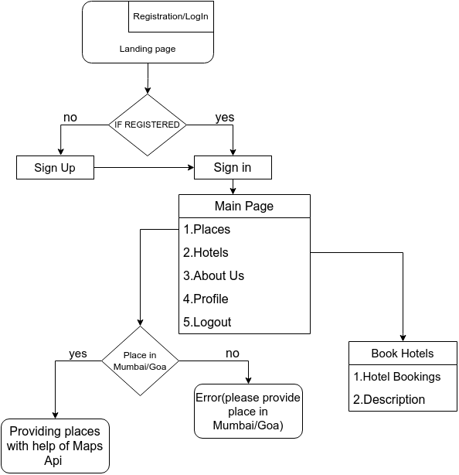

**1.**

**Landing Page**

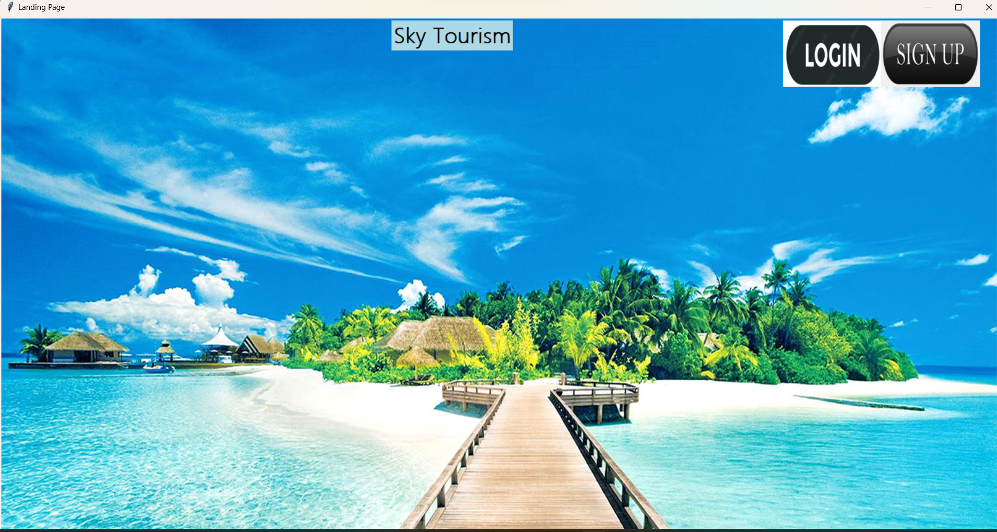

**2.**

**SignUp**

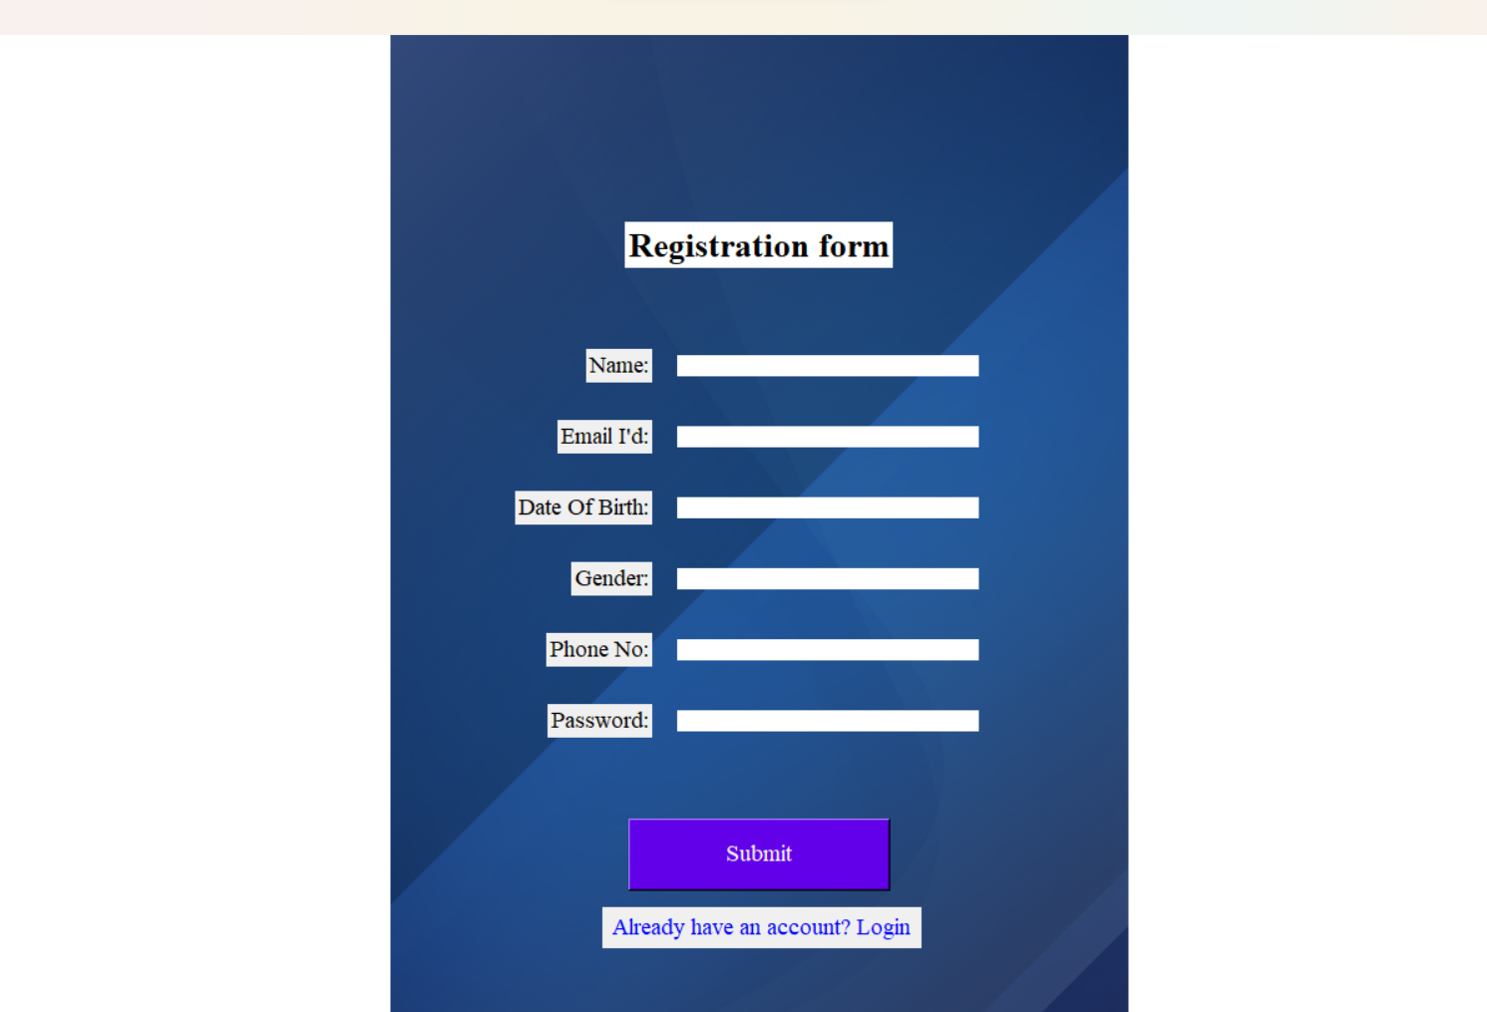

**3.Login**

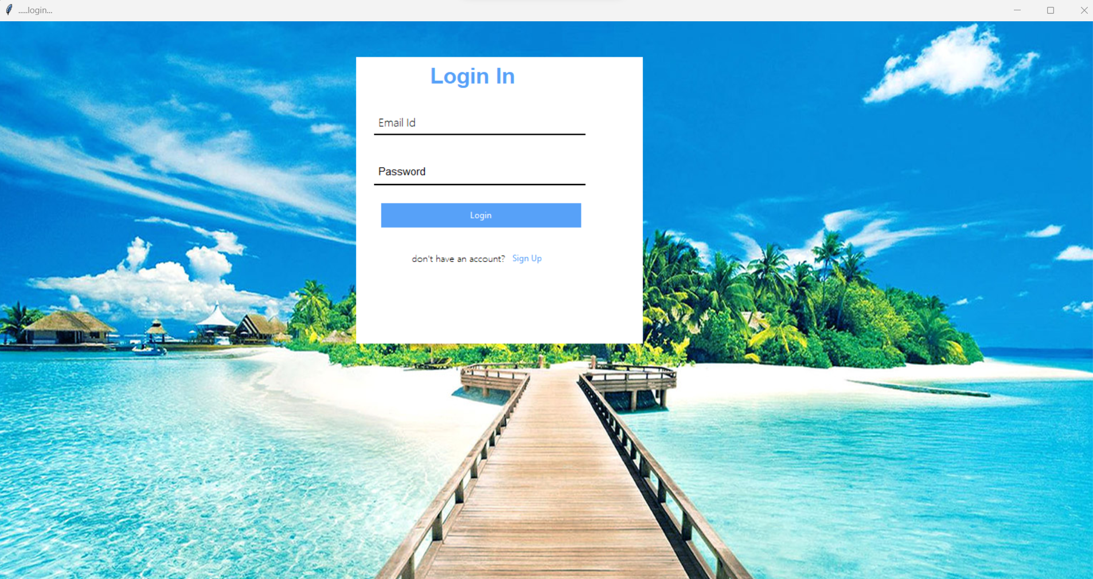

**4.Main Page**

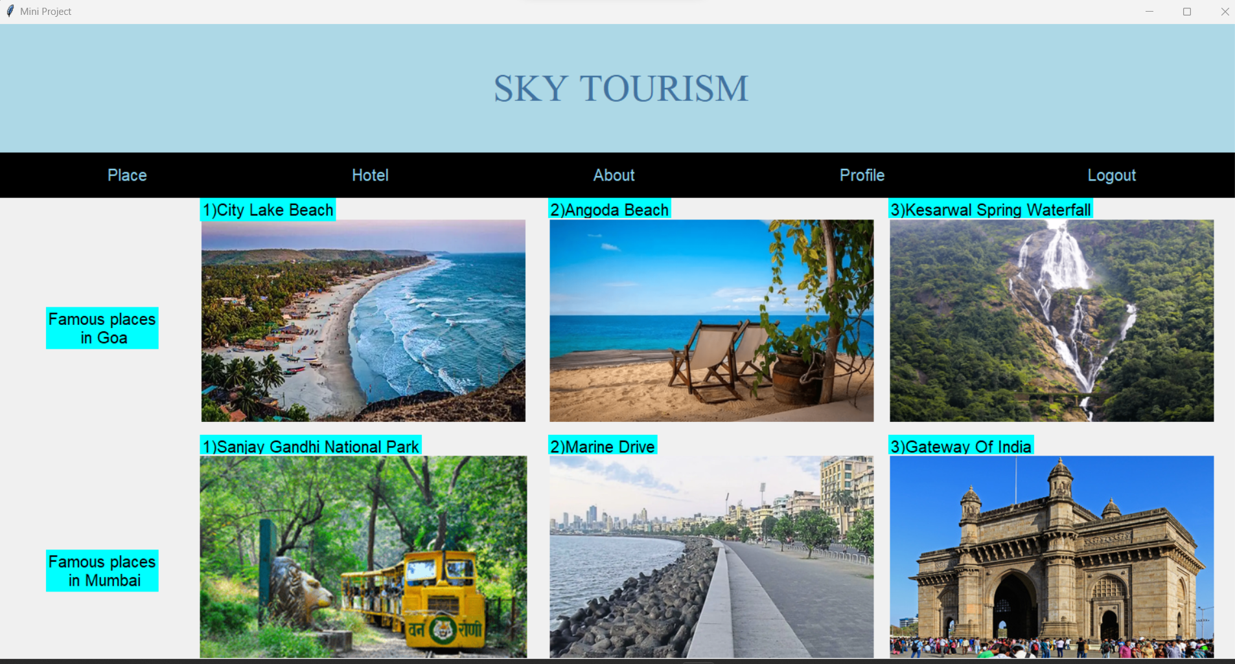

**5)ProfilePage** 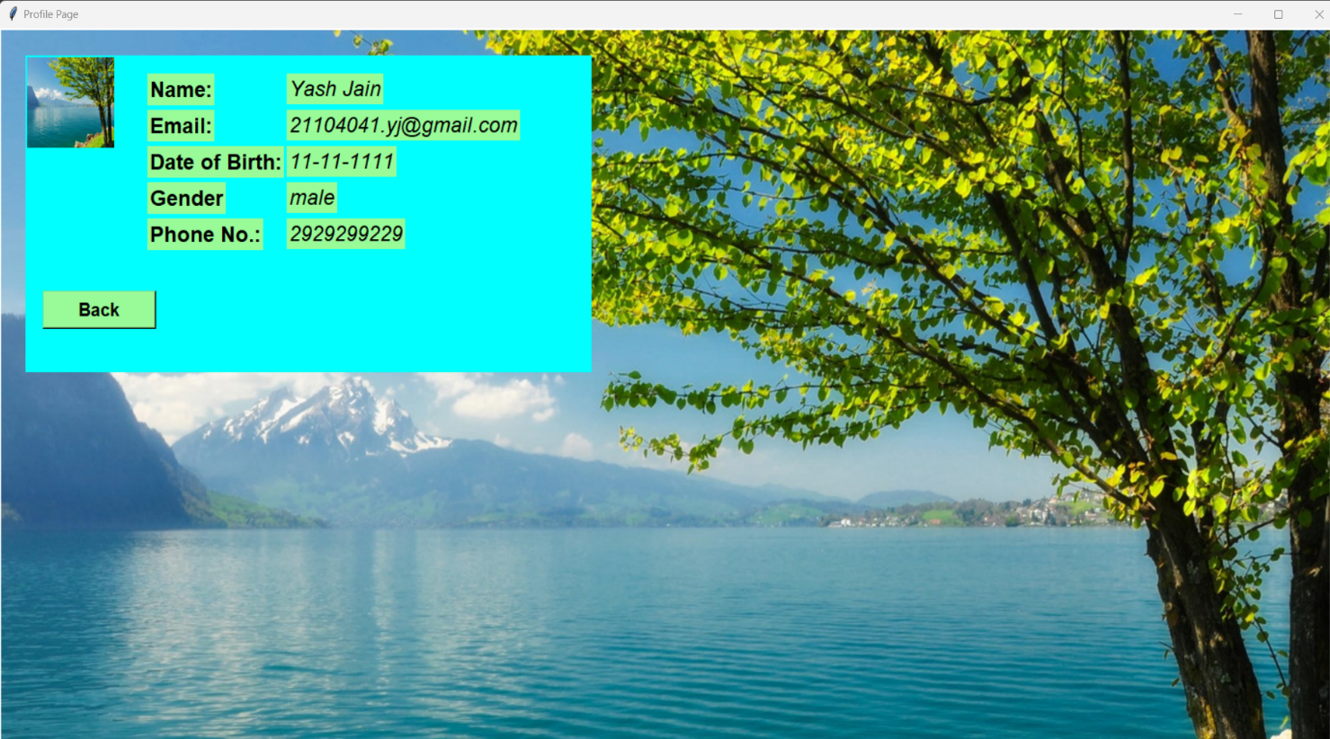

**6)Near By Places**

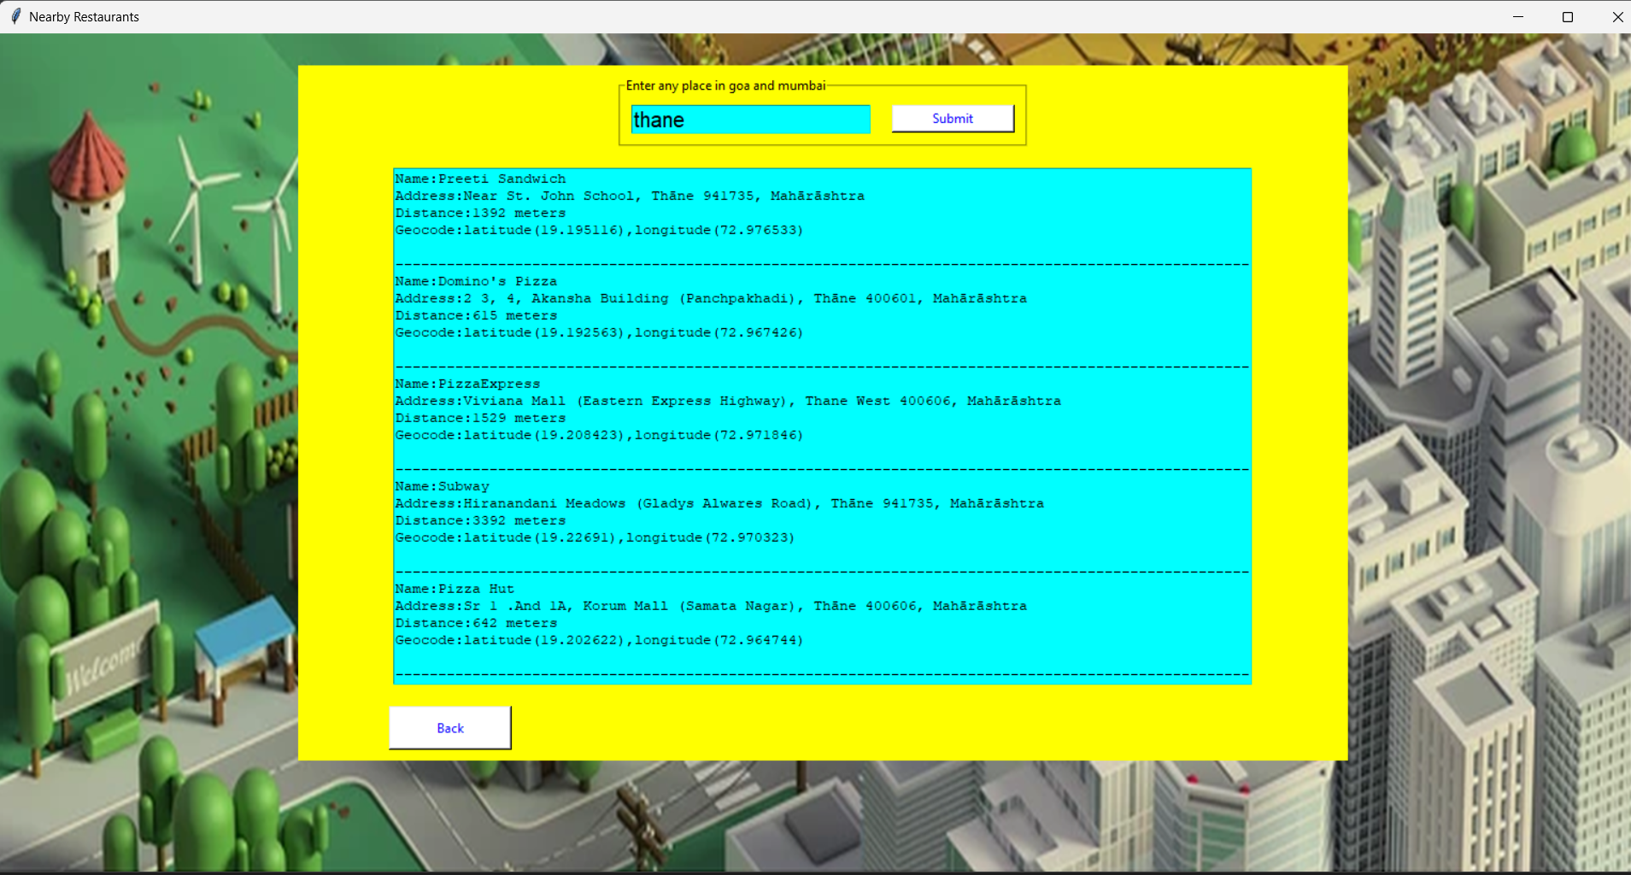

7) Hotel Gui

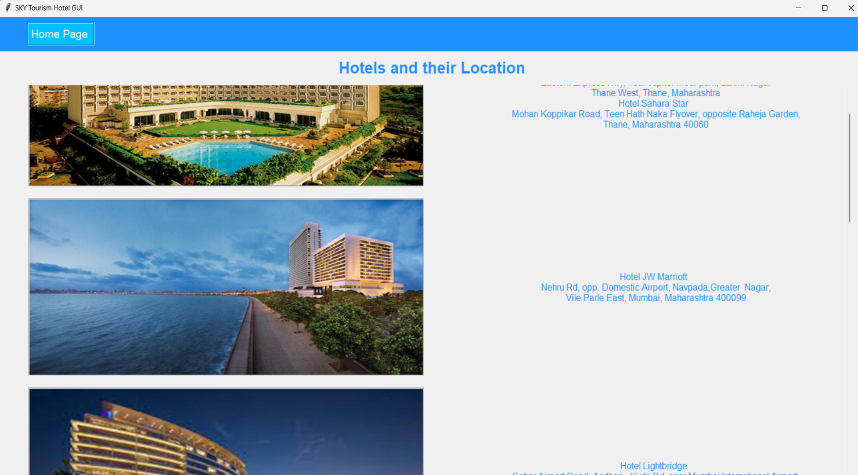

8) About Us

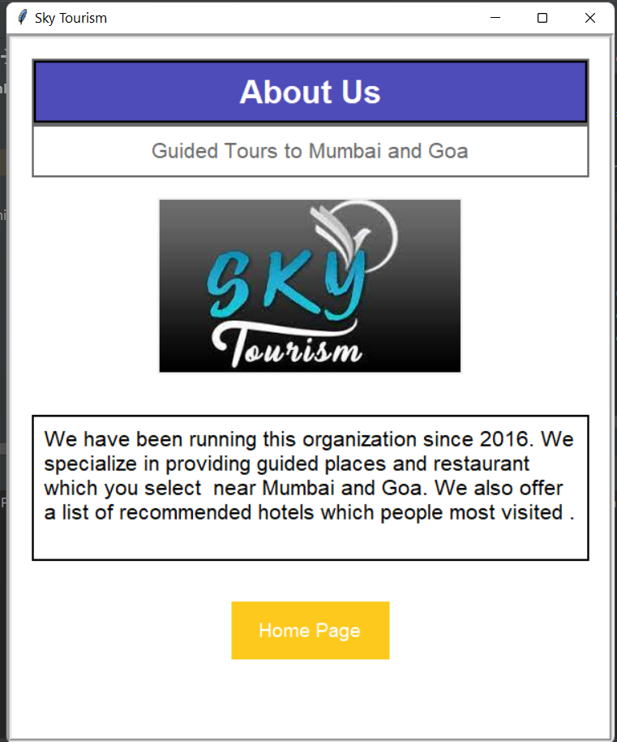

# Chapter 7

# Project Scheduling

|  |  |  |  |
| --- | --- | --- | --- |
| **Sr.**  **No** | **Group Member** | **Time duration** | **Work to be done** |
| **1.** | Karan Jain  Swapnil Joshi  Yash Jain | In the month of  January. | Creating GUI using Tkinter design of Landing page,registration page |
| **2.** | In the month of  February. | Adding more features like Profile,Places,and Main page |
| **3.** | In the month of  March and April. | Completed with database and hotels pages,gui of places and profile page |

**Chapter 8**

## Conclusion:

Hence we conclude by saying that we have successfully completed a Tourist guidance System with a rich GUI interface. This project will help all the people who are traveling in different parts of the city to decide where they have to travel within their budget and time .This will save user time and prevent users from getting misguided by local people in terms of entry fee to visit any particular place and monuments. If some site/view point in the city is not famous through our webpage we would be promoting the spot. More and more tourists would be attracted which in turn will benefit the economy and the growth of the country. will become fruitful if you understand how to overcome these challenges faced by travel agencies. This process achieves its main goal by pertaining to real-time data. The tour management website contributes a reasonable way for the users to schedule their trips, since it provides detailed information about the tourist places including description, image and map.

**References:**

1. <https://developer.foursquare.com/>.
2. <https://www.geeksforgeeks.org/>
3. https://www.w3schools.com/
4. Introduction to Computing and Problem solving using Python--E Balagurusam
5. The complete Reference --Martin C. Brown